 | Министерство науки и высшего образования Российской Федерации  Калужский филиал  федерального государственного бюджетного  образовательного учреждения высшего образования  «Московский государственный технический университет имени Н.Э. Баумана (национальный исследовательский университет)»  (КФ МГТУ им. Н.Э. Баумана)
ФАКУЛЬТЕТ _ИУК «Информатика и управление»______________
КАФЕДРА __ИУК4 «Программное обеспечение ЭВМ и информационные технологии»_____

ДОМАШНЯЯ РАБОТА

ДИСЦИПЛИНА: «ПРОЕКТИРОВАНИЕ СИСТЕМ ХРАНЕНИЯ И ОБРАБОТКИ ДАННЫХ»

Выполнил: студент гр. ИУК4-52Б |  | _________________ (_____Губин Е.В._____)  (Подпись) (Ф.И.О.)
Проверил: |  | _________________ (____Глебов С.А._____)  (Подпись) (Ф.И.О.)
Дата сдачи (защиты):
Результаты сдачи (защиты):
- Балльная оценка:
- Оценка:

Калуга , 2024

Цель: Разработка клиентского приложения (CRUD-операции с таблицами БД)

Сервер

Роутер для постов:

import { Router } from "express";
import postController from "../controllers/post-controller";
import authMiddleware from "../middlewares/auth-middleware";
import { param } from "express-validator";

const postRouter = Router();

postRouter.post("/", authMiddleware, postController.newPost);
postRouter.get("/all", authMiddleware, postController.getAllPosts)
postRouter.get(
"/repost/:childrenPostId",
param("childrenPostId").isNumeric(),
authMiddleware,
postController.getPostsByChildrenPostId
);
postRouter.get(
"/posts/:userId",
param("userId").isNumeric(),
authMiddleware,
postController.getPostsByUserId
);
postRouter.get(
"/:postId",
param("postId").isNumeric(),
authMiddleware,
postController.getPostBytId
);
postRouter.delete(
"/:postId",
param("postId").isNumeric(),
authMiddleware,
postController.deletePost
);

export default postRouter;

Контроллер для постов:

import { NextFunction, Request, Response } from "express";
import INewPost from "../interfaces/INewPost";
import postService from "../services/post-service";
import { validationResult } from "express-validator";
import ApiError from "../exceptions/ApiError";

class PostController {
async newPost(req: Request, res: Response, next: NextFunction) {
try {
const newPost: INewPost = req.body;
const authorId = Number(res.locals.userData.userId);
const newPostData = await postService.newPost(newPost, authorId);
res.json({ ...newPostData });
} catch (error) {
next(error);
}
}

async getPostsByUserId(req: Request, res: Response, next: NextFunction) {
try {
const errors = validationResult(req);
if (!errors.isEmpty()) {
throw ApiError.BadRequest("Incorrect userId", errors.array());
}
const userId = Number(req.params.userId);
const posts = await postService.getPostsByUserId(userId);
res.json({ posts });
} catch (error) {
next(error);
}
}

async getPostBytId(req: Request, res: Response, next: NextFunction) {
try {
const errors = validationResult(req);
if (!errors.isEmpty()) {
throw ApiError.BadRequest("Incorrect post id", errors.array());
}
const postId = Number(req.params.postId);
const postData = await postService.getPostById(postId);
res.json({ ...postData });
} catch (error) {
next(error);
}
}

async deletePost(req: Request, res: Response, next: NextFunction) {
try {
const errors = validationResult(req);
if (!errors.isEmpty()) {
throw ApiError.BadRequest("Incorrect postId", errors.array());
}
const postId = Number(req.params.postId);
const post = await postService.deletePostById(postId);
res.json({ ...post });
} catch (error) {
next(error);
}
}

async getPostsByChildrenPostId(
req: Request,
res: Response,
next: NextFunction
) {
try {
const errors = validationResult(req);
if (!errors.isEmpty()) {
throw ApiError.BadRequest(
"Incorrect children post id",
errors.array()
);
}
const childrenPostId = Number(req.params.childrenPostId);
const posts = await postService.getPostsByChildrenPostId(
childrenPostId
);
res.json({ posts });
} catch (error) {
next(error);
}
}

async getAllPosts(req: Request, res: Response, next: NextFunction) {
try {
const posts = await postService.getAllPosts();
res.json({ posts });
} catch (error) {
next(error);
}
}
}

export default new PostController();

Сервис для постов:

import INewPost from "../interfaces/INewPost";
import db from "../db";
import IPostFromDataBase from "../interfaces/IPostFromDataBase";
import PostDto from "../dtos/post-dto";
import userService from "./user-service";
import ApiError from "../exceptions/ApiError";
import dateTimeService from "./dateTime-service";

class PostService {
async newPost(newPost: INewPost, authorId: number) {
if (!(await userService.userIsExistsById(authorId))) {
throw ApiError.BadRequest("User with this id aren't exist");
}
if (
newPost.childrenPostId &&
!(await this.postIsExistsById(newPost.childrenPostId))
) {
throw ApiError.BadRequest("Children post isn't found");
}

const nowFormattedDateTime = dateTimeService.getNowDate();

const postFromDataBase: IPostFromDataBase = (
await db.query(
`INSERT INTO posts (content, publication_date_time, children_post_id, post_author_id) VALUES ($1, $2, $3, $4) RETURNING *`,
[
newPost.content,
nowFormattedDateTime,
newPost.childrenPostId,
authorId,
]
)
).rows[0];

postFromDataBase.publication_date_time = dateTimeService.formatDateTime(
postFromDataBase.publication_date_time
);

return new PostDto(postFromDataBase);
}

async getPostsByUserId(userId: number) {
if (!(await userService.userIsExistsById(userId))) {
throw ApiError.BadRequest("User with this id aren't exist");
}
if (await userService.userIsExistsById(userId)) {
const posts: IPostFromDataBase[] = (
await db.query(
`SELECT * FROM posts WHERE post_author_id = $1`,
[userId]
)
).rows;
return posts.map((post) => {
post.publication_date_time = dateTimeService.formatDateTime(
post.publication_date_time
);
return new PostDto(post);
});
}
throw ApiError.BadRequest("User with this id aren't exists");
}

async getPostById(postId: number) {
if (!(await this.postIsExistsById(postId))) {
throw ApiError.ResourseNotFound();
}
const postData: IPostFromDataBase = (
await db.query("SELECT * FROM posts WHERE post_id = $1", [postId])
).rows[0];
postData.publication_date_time = dateTimeService.formatDateTime(
postData.publication_date_time
);
return new PostDto(postData);
}

async deletePostById(postId: number) {
if (await this.postIsExistsById(postId)) {
const post: IPostFromDataBase = (
await db.query(
"DELETE FROM posts WHERE post_id = $1 RETURNING *",
[postId]
)
).rows[0];
post.publication_date_time = dateTimeService.formatDateTime(
post.publication_date_time
);
return new PostDto(post);
}
throw ApiError.BadRequest("Post with this id aren't found");
}

async postIsExistsById(postId: number) {
const postById: IPostFromDataBase[] = (
await db.query(`SELECT * FROM posts WHERE post_id = $1`, [postId])
).rows;
if (postById.length == 0) {
return false;
}
return true;
}

async getPostsByChildrenPostId(childrenPostId: number) {
if (!(await this.postIsExistsById(childrenPostId))) {
throw ApiError.BadRequest("Children post isn't found");
}
const posts: IPostFromDataBase[] = (
await db.query("SELECT * FROM posts WHERE children_post_id = $1", [
childrenPostId,
])
).rows;
return posts.map((post) => {
post.publication_date_time = dateTimeService.formatDateTime(
post.publication_date_time
);
return new PostDto(post);
});
}

async getPostIdsByAuthorId(authorId: number) {
if (!(await userService.userIsExistsById(authorId))) {
throw ApiError.BadRequest("Author id isn't found");
}
const ids: number[] = (
await db.query(
"SELECT post_id FROM posts WHERE post_author_id = $1",
[authorId]
)
).rows;
return ids;
}

async getAllPosts() {
const posts: IPostFromDataBase[] = (
await db.query("SELECT * FROM posts", [])
).rows;
return posts.map((post) => {
post.publication_date_time = dateTimeService.formatDateTime(
post.publication_date_time
);
return new PostDto(post);
});
}
}

export default new PostService();

Клиент

Axios для работы с сервером над постами:

import $api from "../http";
import IGetPost from "../interfaces/IResponses/IGetPost";

export default class PostService {
static async getPostsByUserId(userId: number) {
return await $api.get<{ posts: IGetPost[] }>(`/post/posts/${userId}`);
}

static async getPostById(postId: number) {
return await $api.get<IGetPost>(`/post/${postId}`);
}

static async getPostsByChildrenPostId(childrenPostId: number) {
return await $api.get<{ posts: IGetPost[] }>(
`/post/repost/${childrenPostId}`
);
}

static async newPost(
content: string,
childrenPostId: number | null = null
) {
return await $api.post<IGetPost>("/post", { content, childrenPostId });
}

static async deletePost(postId: number) {
return await $api.delete<IGetPost>(`/post/${postId}`);
}

static async getALlPosts() {
return await $api.get<{ posts: IGetPost[] }>("/post/all");
}
}

Пользовательский интерфейс

Компонент пост:

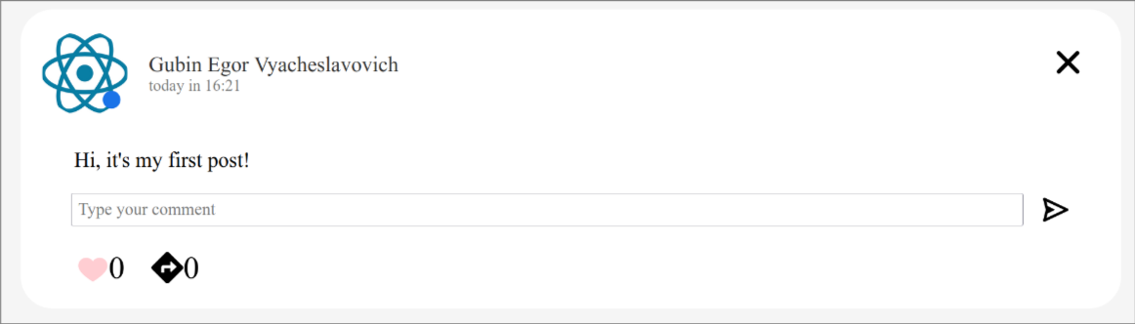Рис. 1: Пост
import React, { ChangeEvent, useContext, useEffect, useState } from "react";
import s from "./Post.module.css";
import IPost from "../../interfaces/IProps/IPost";
import DateTimeService from "../../services/dateTime-service";
import PostService from "../../services/post-service";
import IGetPost from "../../interfaces/IResponses/IGetPost";
import IUser from "../../interfaces/IResponses/IUser";
import UserService from "../../services/user-service";
import ProfileImageService from "../../services/profileImage-service";
import classNames from "classnames";
import IGetComment from "../../interfaces/IResponses/IGetComment";
import Comment from "../Comment/Comment";
import CommentService from "../../services/comment-service";
import { BiSend } from "react-icons/bi";
import { FcLikePlaceholder } from "react-icons/fc";
import { FcLike } from "react-icons/fc";
import ReactionService from "../../services/reaction-service";
import IGetReaction from "../../interfaces/IResponses/IGetReaction";
import { Context } from "../..";
import { FaDirections } from "react-icons/fa";
import { observer } from "mobx-react-lite";
import { IoClose } from "react-icons/io5";
import PostImageService from "../../services/postImage-service";
import ImageSlider from "../ImageSlider/ImageSlider";
import { useNavigate } from "react-router-dom";
import io from "socket.io-client";
import { globalSocket } from "../../globalSocket";
import { GrStatusGoodSmall } from "react-icons/gr";

const Post: React.FC<IPost> = ({
post,
isChild,
setCreatePostFormIsOpened,
setRepost,
setPosts,
}) => {
const { store } = useContext(Context);

const [postAvatarImage, setPostAvatarImage] = useState("");
const [author, setAuthor] = useState({} as IUser);
const [postImages, setPostImages] = useState<string[]>([]);
const [comments, setComments] = useState<IGetComment[]>([]);
const [childPost, setChildPost] = useState<JSX.Element | null>(null);
const [showAllComments, setShowAllComments] = useState<boolean>(false);
const [newComment, setNewComment] = useState("");
const [isReaction, setIsReaction] = useState(false);
const [reactionsAmount, setReactionsAmount] = useState(0);
const [repostsAmount, setRepostsAmount] = useState(0);
const [isOnline, setIsOnline] = useState(false)

const navigate = useNavigate();

const openPageByAvatar = () => {
if (store.user.userId !== post.postAuthorId) {
navigate(`/profile/${post.postAuthorId}`);
}
};

const loadPostAvatarImage = async () => {
setPostAvatarImage(
(await ProfileImageService.getProfileImage(post.postAuthorId)).data
.src
);
};

const loadAuthor = async () => {
setAuthor((await UserService.getUserById(post.postAuthorId)).data);
};

const loadPostImages = async () => {
setPostImages(
(await PostImageService.getPostImages(post.postId)).data.postImages
);
};

const loadComments = async () => {
setComments(
(
await CommentService.getCommentsByPostId(post.postId)
).data.comments.sort((first, second) => {
const dateFirst = new Date(first.commentDateTime);
const dateSecond = new Date(second.commentDateTime);
return dateSecond.getTime() - dateFirst.getTime();
})
);
};

const loadChildPost = async () => {
if (post.childrenPostId) {
const childPostData = (
await PostService.getPostById(post.childrenPostId)
).data;
setChildPost(<Post post={childPostData} isChild={true} />);
}
};

const laodReactions = async () => {
const reactionsData = (
await ReactionService.getReactionsByPostId(post.postId)
).data.reactions;
setReactionsAmount(reactionsData.length);
for (let i = 0; i < reactionsData.length; i++) {
if (reactionsData[i].reactionAuthorId === store.user.userId) {
setIsReaction(true);
return;
}
}
};

const loadReposts = async () => {
setRepostsAmount(
(await PostService.getPostsByChildrenPostId(post.postId)).data.posts
.length
);
};

const loadIsOnline = async () => {
setIsOnline((await UserService.getStatus(post.postAuthorId)).data.isOnline)
}

useEffect(() => {
loadAuthor();
loadPostImages();
loadChildPost();
loadPostAvatarImage();
laodReactions();
loadReposts();
loadIsOnline()
if (!isChild) {
loadComments();
}
const socket = io(globalSocket);
socket.emit("subscribe_image", {
userId: post.postAuthorId,
});
socket.emit("subscribe_like", {
postId: post.postId,
authorId: store.user.userId,
});
socket.emit("subscribe_online", {userId: post.postAuthorId });
socket.on("set_image", () => {
loadPostAvatarImage();
});
socket.on("set_like", ({ operation }: { operation: number }) => {
console.log(operation)
setReactionsAmount((prev) => prev + operation);
});
socket.on("set_status", ({ isOnline }: { isOnline: boolean }) => {
setIsOnline(isOnline);
});
return () => {
socket.off("set_status");
socket.off("set_like");
socket.off("set_image");
socket.disconnect();
};
}, []);

return (
<div className={classNames(s.post, { [s.left_border]: isChild })}>
<div className={s.post_header}>
<div
className={s.profile_post_image}
onClick={openPageByAvatar}
style={{
backgroundImage: `url(${postAvatarImage})`,
}}
>
{isOnline && (
<GrStatusGoodSmall className={s.online} />
)}</div>
<div className={s.date_time_fio}>
<div className={s.post_fio}>
{[
author.lastName,
author.firstName,
author.patronymic,
].join(" ")}
</div>
<div className={s.pub_post_date_time}>
{DateTimeService.formDate(post.publicationDateTime)}
</div>
</div>
</div>
<div className={s.post_content}>{post.content}</div>
<ImageSlider images={postImages} />
{childPost}
{comments.length !== 0 &&
comments.map((comment, index) => {
if (showAllComments || comments.length <= 2)
return (
<Comment
isMyPost={
store.user.userId === post.postAuthorId
}
comment={comment}
key={comment.commentId}
setComments={setComments}
/>
);
if (index <= 1)
return (
<Comment
isMyPost={
store.user.userId === post.postAuthorId
}
comment={comment}
key={comment.commentId}
setComments={setComments}
/>
);
return null;
})}
{comments.length > 2 ? (
showAllComments ? (
<span
className={s.manage_comments}
onClick={() => setShowAllComments(false)}
>
Hide comments
</span>
) : (
<span
className={s.manage_comments}
onClick={() => setShowAllComments(true)}
>
Show all commets...
</span>
)
) : null}
{!isChild ? (
<div className={s.new_comment}>
<textarea
placeholder="Type your comment"
className={s.comment_area}
rows={1}
value={newComment}
onChange={(event) => {
const textarea = event.target;

textarea.style.height = "auto";

textarea.style.height =
textarea.scrollHeight + "px";
setNewComment(event.target.value);
}}
></textarea>
<BiSend
onClick={() => {
CommentService.newComment(newComment, post.postId)
.then((response) => response.data)
.then((data) =>
setComments((prev) => [data, ...prev])
);
setNewComment("");
}}
className={s.send_comment}
/>
</div>
) : null}
{isChild ? null : (
<div className={s.reaction_repost}>
<div
className={s.reactions_amount}
onClick={
isReaction
? () => {
ReactionService.deleteReaction(
post.postId
)
.then((response) => response.data)
.then((data) => {
setReactionsAmount(
(prev) => prev - 1
);
setIsReaction(false);
});
const socket = io(globalSocket);
socket.emit("change_like", {
postId: post.postId,
operation: -1,
authorId: store.user.userId,
});
}
: () => {
ReactionService.newReaction(post.postId)
.then((response) => response.data)
.then((data) => {
setReactionsAmount(
(prev) => prev + 1
);
setIsReaction(true);
});
const socket = io(globalSocket);
socket.emit("change_like", {
postId: post.postId,
operation: 1,
authorId: store.user.userId,
});
}
}
>
{isReaction ? (
<FcLike className={s.reaction_button} />
) : (
<FcLikePlaceholder className={s.reaction_button} />
)}{" "}
{reactionsAmount}{" "}
</div>
<div
className={classNames({
[s.reposts_amount]:
post.postAuthorId !== store.user.userId,
[s.repost_amount_unself]:
post.postAuthorId === store.user.userId,
})}
onClick={
post.postAuthorId === store.user.userId
? () => {}
: () => {
if (
setCreatePostFormIsOpened &&
setRepost
) {
setCreatePostFormIsOpened(true);
setRepost(post);
}
}
}
>
<FaDirections className={s.repost_button} />{" "}
{repostsAmount}
</div>
</div>
)}
{isChild || post.postAuthorId !== store.user.userId ? null : (
<IoClose
className={s.close}
onClick={() => {
PostService.deletePost(post.postId)
.then((response) => response.data)
.then((data) => {
if (setPosts)
setPosts((prev) =>
prev.filter(
(postData) =>
postData.postId !== post.postId
)
);
const socket = io(globalSocket);
socket.emit("delete_post", {
postId: data.postId,
authorId: data.postAuthorId,
});
});
}}
/>
)}
</div>
);
};

export default observer(Post);

Форма для создания поста:

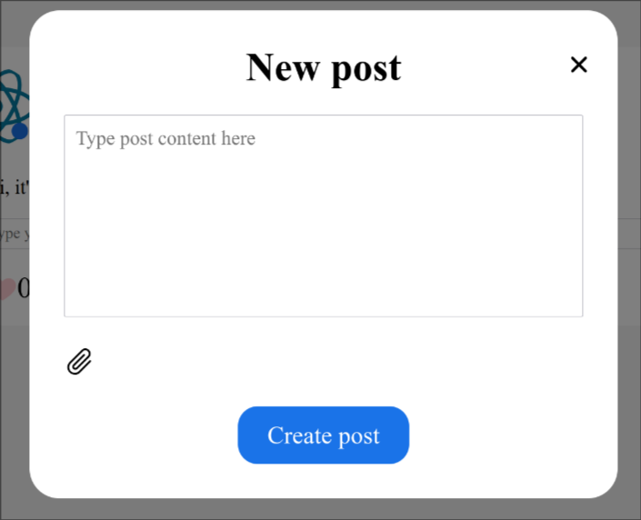Рис. 2: Форма для создания поста
import React, { ChangeEvent, useRef, useState } from "react";
import s from "./NewPostForm.module.css";
import { FormButton } from "../UI/FormButton/FormButton";
import { GoPaperclip } from "react-icons/go";
import PostService from "../../services/post-service";
import PostImageService from "../../services/postImage-service";
import INewPostForm from "../../interfaces/IProps/INewPostForm";
import io from "socket.io-client";
import { globalSocket } from "../../globalSocket";

export const NewPostForm: React.FC<INewPostForm> = ({
setPosts,
repost,
setRepost,
setCreatePostFormIsOpened,
isFromPostsPage,
}) => {
const [content, setContent] = useState("");
const fileInputRef = useRef<HTMLInputElement>(null);
const [files, setFiles] = useState<File[]>([]);
const [filesImages, setFilesImages] = useState<string[]>([]);

const setImages = (event: ChangeEvent<HTMLInputElement>) => {
const filesEvent = event.target.files;
if (!filesEvent || filesEvent.length === 0) {
return;
}
const permittedTypes = ["image/jpeg", "image/jpg", "image/png"];
for (let i = 0; i < filesEvent.length; i++) {
if (!permittedTypes.includes(filesEvent[i].type)) {
return;
}
}
const filesArray = Array.from(filesEvent);
setFiles(filesArray);
setFilesImages(
filesArray.map(
(fileData) => `url(${URL.createObjectURL(fileData)})`
)
);
};

return (
<div className={s.new_post_form}>
<div className={s.container}>
<textarea
rows={8}
placeholder="Type post content here"
className={s.content}
value={content}
onChange={(event) => setContent(event.target.value)}
></textarea>
<div className={s.selected_images}>
<GoPaperclip
className={s.clip}
onClick={() => fileInputRef.current?.click()}
/>
{filesImages.map((file) => (
<div
className={s.image}
style={{
backgroundImage: file,
}}
></div>
))}
</div>
<input
ref={fileInputRef}
type="file"
multiple={true}
accept=".jpg, .jpeg, .png"
onChange={setImages}
className={s.file_input}
/>
</div>
<FormButton
onClick={
repost
? async () => {
const post = (
await PostService.newPost(
content,
repost.postId
)
).data;
await PostImageService.newPostImages(
files,
post.postId
);
setRepost(null);
setContent("");
setFiles([]);
setFilesImages([]);
setCreatePostFormIsOpened(false);
if (isFromPostsPage)
setPosts((prev) => [post, ...prev]);
const socket = io(globalSocket);
socket.emit("new_post", { post });
}
: async () => {
const post = (await PostService.newPost(content))
.data;
await PostImageService.newPostImages(
files,
post.postId
);
setContent("");
setFiles([]);
setFilesImages([]);
setCreatePostFormIsOpened(false);
setPosts((prev) => [post, ...prev]);
const socket = io(globalSocket);
socket.emit("new_post", { post });
}
}
type="button"
>
Create post
</FormButton>
</div>
);
};

Страница постов:

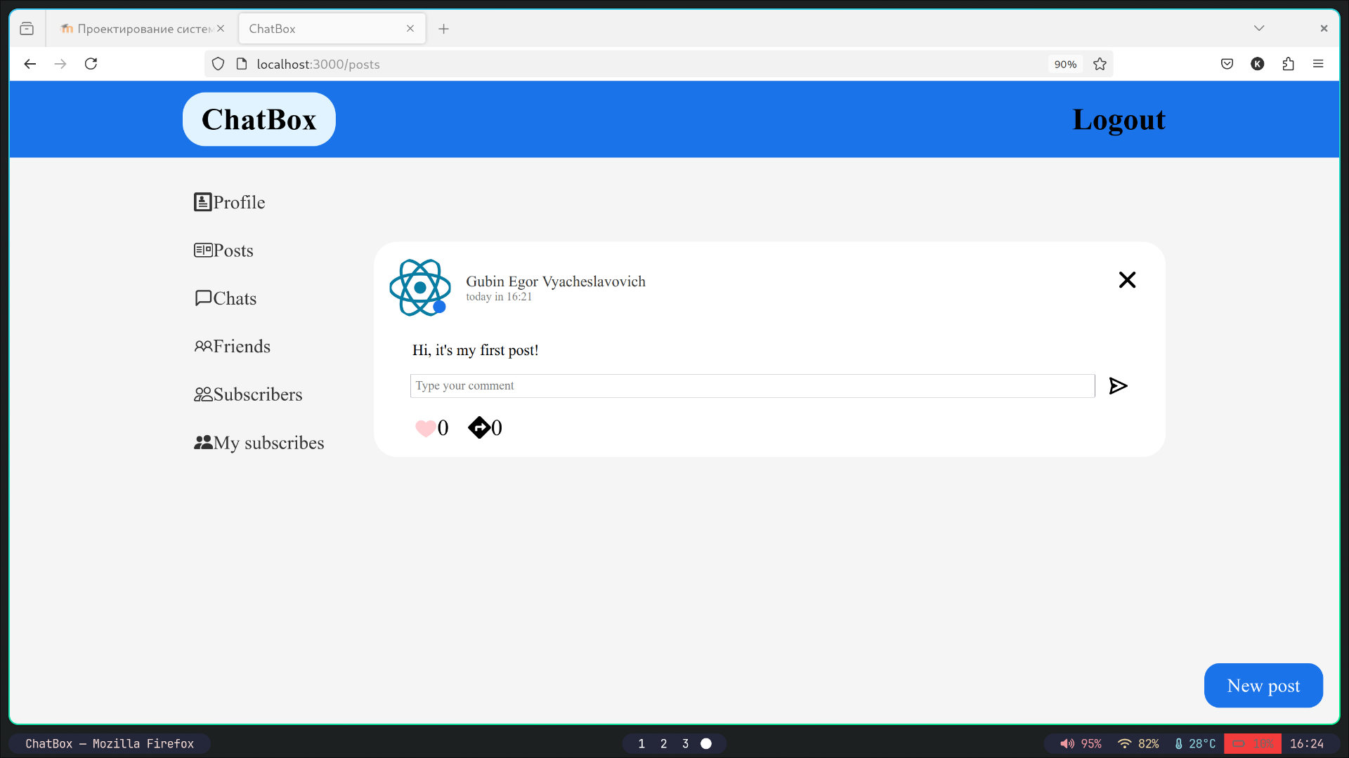Рис. 3: Страница постов
import React, { useEffect, useState } from "react";
import s from "./PostsPage.module.css";
import IGetPost from "../../interfaces/IResponses/IGetPost";
import PostService from "../../services/post-service";
import Post from "../Post/Post";
import { ModalWindow } from "../ModalWindow/ModalWindow";
import { NewPostForm } from "../NewPostForm/NewPostForm";
import { FormButton } from "../UI/FormButton/FormButton";

export const PostsPage: React.FC = () => {
const [posts, setPosts] = useState<IGetPost[]>([]);
const [createPostFormIsOpened, setCreatePostFormIsOpened] = useState(false);
const [repost, setRepost] = useState<IGetPost | null>(null);

const loadPosts = async () => {
const postsData = (await PostService.getALlPosts()).data.posts;
setPosts(
postsData.sort((first, second) => {
const dateFirst = new Date(first.publicationDateTime);
const dateSecond = new Date(second.publicationDateTime);
return dateSecond.getTime() - dateFirst.getTime();
})
);
};

useEffect(() => {
loadPosts();
}, []);

return (
<div>
{posts.map((post) => (
<Post
key={post.postId}
post={post}
isChild={false}
setRepost={setRepost}
setCreatePostFormIsOpened={setCreatePostFormIsOpened}
setPosts={setPosts}
/>
))}
<FormButton
className={s.new_post}
type="button"
onClick={() => setCreatePostFormIsOpened(true)}
>
New post
</FormButton>
<ModalWindow
isOpened={createPostFormIsOpened}
setIsOpened={setCreatePostFormIsOpened}
header="New post"
>
<NewPostForm
setCreatePostFormIsOpened={setCreatePostFormIsOpened}
setPosts={setPosts}
repost={repost}
setRepost={setRepost}
isFromPostsPage={true}
/>
</ModalWindow>
</div>
);
};

Вывод: в ходе лабораторной работы были реализованы CRUD операции для работы с постами.

